Exam Nerves and Anxiety: tapping it away
This method of relieving anxiety and stress might seem a bit whacky, but it has been tried and tested; so try and keep an open mind. It’s been around since the 1970s and was developed by psychology professor Dr. Roger Callahan who discovered he could collapse negative emotions by tapping certain meridian points on his patients (acupuncture works on meridian points too).

The good thing about tapping therapy is that it
- Is easy to do,
- Doesn't take much time,
- Is right at your fingertips (call it up anytime, anyplace) and
- Has no negative side effects.
It is not about eradicating memories, but rather about eradicating the effect of those memories.

There are two exercises below which can be completed in less than five minutes. The important thing to remember is to think about your fear, worry or anxiety during the tapping exercises. If you have several anxieties, you may need to repeat the procedure while tuning into each one separately. As with any skill, practice is important; doing so will help you do them quickly and without thinking – and especially just before the exam.

By the way, you can also do these during your revision period where things might feel overwhelming for you.

THE FIRST EXERCISE
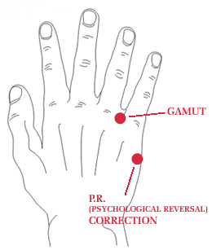
Part one: Psychological Reversal
This part of the exercise is to correct something called ‘Psychological Reversal’ (PR): in which the electrical polarity of the body’s meridian energy system is reversed. A good analogy is a battery powered torch: put the batteries in the wrong way round and it simply won’t work.

Some examples that indicate PR include
- Putting an empty milk carton back in the fridge.
- Typing two letters in a word the wrong way round.
- Saying left when you mean right or north when you mean south and vice versa.
- Writer’s block or poor concentration (reading things over and over again).

To correct Psychological Reversal: tap (with two fingers) the side of the hand, on the side where you would do a karate chop (where it says PR on the diagram above). 10 firm (but not painful) taps should be enough. Roughly two taps per second.

The exercises that now follow won’t work for some of you UNLESS you do the Psychological Reversal exercise first. Besides, it’s quick and easy.

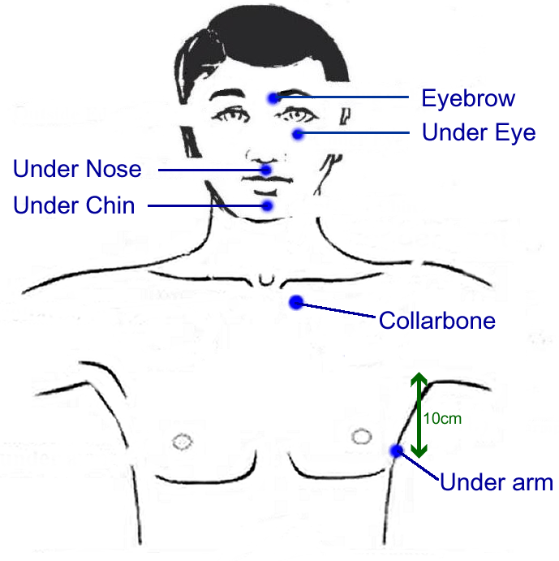
Part Two: The tapping points
Think of your feelings of discomfort or anxiety. Make a picture in your mind of the event you fear or what you fear might happen. Focus on the feelings you get in your body when you think about this. When you’re in touch with these, using two fingers tap solidly on the areas below in sequence.

Remember to continuously think of this discomfort and anxiety continuously throughout the tapping sequence.

Again, the tapping should be firm but not painful (a bit like when you are percussing the chest in a clinical examination). Tap each area for around 8-10 seconds (roughly 2 taps per second). And it doesn’t matter which side of the body you chose to tap.

- Tap under the nose
- Tap on the eyebrow (inner medial aspect)
- Tap under the eye (just beneath the bony ridge)
- Tap under the arm
- Tap on the collar bone (just below the medial end of the clavicle)
- Perform the 9 gamut series(see below)
- Then tap under the nose again
- Then on the eyebrow again
- Then under the eye again
- Then under the arm again
- And finally on the collar bone again

The 9 Gamut Series
This sequence of activities is done while tapping at a spot on the back of either hand. The spot is just below and between the knuckle of the little finger and the knuckle of the ring finger (the interdigital space) – see hand diagram above. With the hand flat, tap this spot continually while doing the following activities (about 5 taps for each of the 9 activities). Each activity is designed to activate a different area of your brain

- CLOSE YOUR EYES
- OPEN YOUR EYES AND LOOK STRAIGHT AHEAD
- NOW LOOK DOWN AND TO THE RIGHT (HEAD STILL)
- THEN LOOK DOWN AND TO THE LEFT (HEAD STILL)
- ROLL EYES IN A COMPLETE CLOCKWISE CIRCLE
- ROLL EYES BACK IN AN ANTICLOCKWISE CIRCLE
- HUM A LITTLE BIT OF A TUNE – like Bah Bah Black Sheep or Jingle Bells (this isolates the right, visual, side of the brain)
- COUNT TO FIVE (to activate the left brain)
- HUM THE LITTLE TUNE AGAIN (back to the right brain)
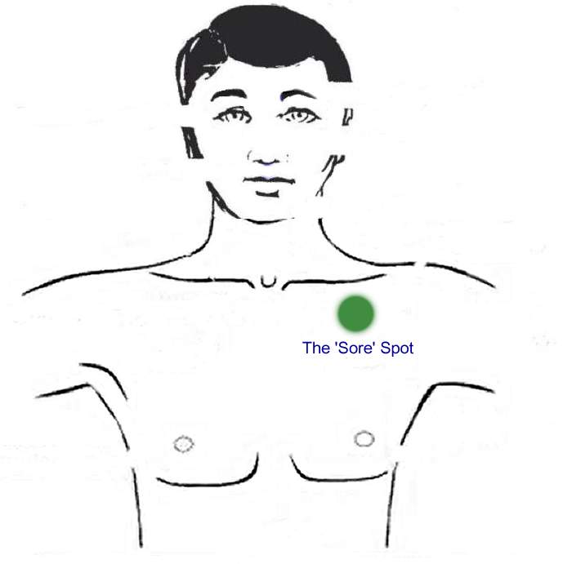

Part Three: The Sore Spot
- Now re-evaluate your anxiety.
- If the intensity hasn’t gone down much, locate the tender area of your upper chest beneath the left collarbone (about half an inch below the middle of the collar bone).
- Press down with your fingers and rub this spot in a circular motion for about 20 seconds whilst still thinking of your anxiety/discomfort.
- Then repeat the tapping sequence as in part two.

Part Four: Floor to ceiling eyeroll
If the anxiety is better but you want to reduce it even more, try this one (but only after you’ve done all the steps above). Continue to tap the gamut point throughout this little exercise. The gamut point is that interdigital space between the little and ring finger as illustrated in the diagram on the first page.
- Whilst you’re tapping the gamut point:
- Hold you head still
- Look down towards the floor
- Gradually to the count of 6 or 7, vertically raise your eyes until looking at the ceiling.
THE SECOND EXERCISE: Collarbone Breathing
The Collarbone breathing exercise is another powerful THREE MINUTE EXERCISE particularly good for anxiety and high stress. Do this twice daily (morning, evening), especially during your revision period (and again, in the morning of the exam). If done on a regular basis, this exercise will help to balance your autonomic nervous system and strengthen and increase your capacity for daily stress.

In the Collarbone Breathing treatment below, when the knuckles touch the body, only they should touch the body. They are a negative polarity, and the palm of the hand, the thumb, and the elbow are a positive polarity. If anything other than the knuckles touch the body during this phase of the treatment, the treatment will not work: in simple terms it will short circuit the treatment.

Where are the collar bone areas to tap? Simple: locate the medial end of the clavicle (collar bone) and it’s one inch below that. Again, during this exercise, you must think about your particular anxiety or discomfort throughout it.
TOP TIP: If you want to see some video clips of these, try typing the following into www.youtube.com
TFT anxiety
TFT stress
Collar bone breathing
Gamut point
Sore spot TFT
Breathing positions
There are five breathing positions in this exercise:
1. Take a deep breath in fully and hold it.
2. Let half of that breath out and hold it.
3. Let it all out and hold it.
4. Take a half breath in and hold it.
5. Breathe normally.

The touching positions
- Put two fingers from one hand on one of the collar bone points. With the other hand, (again with two fingers, tap the gamut spot on the back of the other hand whilst going through the 5 breathing positions. Tap rapidly (around 2 taps per sec) and at least 5 taps for each of the five breathing positions.
- Move the same two fingers to the other collar bone and repeat the process.
- Now, bend the same two fingers in half and touch the knuckles to the collarbone point while tapping and going through the five breathing positions. Either tuck the thumb in or keep it in the air. Make sure that the elbows are in the air when you are touching the knuckles to the body so that only the knuckles are touching the body.
- Move knuckles to the other collarbone point and repeat the process. Tuck the thumb in and keep the elbow out of the way.
- Now, take fingertips of OTHER hand and repeat steps 1 and 2 above.
- Now, take knuckles of that hand and repeat steps 3 and 4 above, making sure that only the knuckles are touching the body.

Some Notes: The area below the collar bone is linked to the hypothalamus, which controls emotions.

